STUDENT LESSON

AB29 – Linked List
Student Lesson

AB29 – Linked List

INTRODUCTION: In this lesson, you will study a new data structure, the linked list, which is used to implement a list of elements arranged in some kind of order. This is the backbone of the LinkedList class that is part of the Java Collections. The linked list structure uses memory that shrinks and grows as needed but not in the same way as arrays. The discussion of linked lists includes the specification and implementation of a node class. This curriculum will use the node class suggested by College Board.

This lesson will present the common manipulations performed on a linked list: adding, removing and traversing. The concepts from this lesson will provide us with the tools to build our own more advanced data structure, the binary search tree.

The key topics for this lesson are:

A. Declarations for a Linked List
B. Methods for Manipulating Nodes
C. Implementing Linked Lists
D. Traversing a Linked List - Method printList
- Pitfalls of Linked Data Structures
- Building an Ordered Linked List
- Linked List Algorithms
- Static vs. Dynamic Data Structures
- Doubly-Linked Lists
- Deleting from a Doubly-Linked List

VOCABULARY: AUXILIARY POINTER DOUBLY-LINKED LIST
EXTERNAL POINTER INTERNAL POINTER
LINKED LIST NODE
NULL REFERENCE TRAVERSE

DISCUSSION: A. Declarations for a Linked List

1. A linked list is a sequence of elements arranged one after another, with each element connected to the next element by a “link.” The link to the next element is combined with each element in a component called a node. A node is represented pictorially as a box with an element written inside of the box and a link drawn as an arrow and used to connect one node to another.

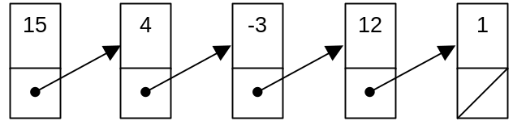

Figure 29-1

In addition to connecting two nodes, the links also place the nodes in a particular order. In Figure 29-1 above, the five nodes form a chain with the first node linked to the second, the second node linked to the third node, and so on until the last node is reached. The last node is a special case since it is not linked to another node and its link is indicated with a diagonal line.

2. Each node contains two pieces of information: an element and a reference to another node. This can be implemented as a Java class for a node using an instance variable to hold the element, and a second instance variable that is a reference to another node as follows.

public class ListNode{
private Object value; // the element stored in this node
private ListNode next; // reference to next node in List
...
}

3. The declaration seems circular and in some ways it is, but the compiler will allow such definitions. A ListNode will have two data members, an Object and a reference to another ListNode. The instance variable next will point to the next ListNode in a linked list.

4. The ListNode class is constructed so that the elements of a list are objects (i.e., have the Object data type). Since any class extends Object, you can put any kind of object into a list, including arrays and strings.

5. Whenever a program builds and manipulates a linked list, the nodes are accessed through one or more references to nodes. Typically, a program includes a reference to the first node (first) and a reference to the last node (last).

ListNode first;
ListNode last;

A program can create a linked list as shown below in Figure 29.2. The first and last reference variables provide access to the first and last nodes of the list.

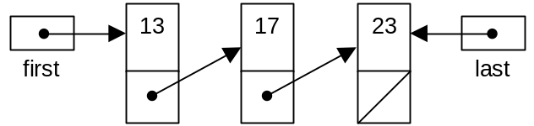

Figure 29-2

6. Figure 29-2 illustrates a linked list with a reference to the first node where the list terminates at the final node (indicated by a diagonal line in the reference field of the last node). Instead of a reference to another node, the final node contains a null reference. Recall that null is a special Java constant that can be used for any reference variable that has nothing to refer to. There are several common situations where the null reference is used:

a. When a reference variable is first declared and there is not yet an object for it to refer to, it can be given an initial value of the null reference.

- The null reference occurs in the link part of the final node of a linked list.

c. When a linked list does not yet have any nodes, the null reference is used for the first and last reference variables to indicate an empty list.

B. Methods for Manipulating Nodes
See ListNode.java | 1. Methods for the ListNode class will consist of those for creating, accessing, and modifying nodes.

2. The constructor for the ListNode class is responsible for creating a node and initializing the two instance variables of a new node.

public ListNode(Object initValue, ListNode initNext) {
// post: constructs a new element with object initValue,
// followed by next element
value = initValue;
next = initNext;
}

3. Here is an example of code to create the first node of a linked list.

ListNode first;
first = new ListNode(new Integer(23), null);

After execution of the two statements, first refers to the header node of a small linked list that contains just one node with the Integer 23.

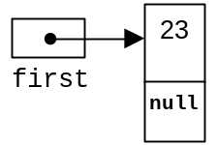

4. Getting and setting the data and link of the node are accomplished with getter and setter methods as follows.

public Object getValue(){
// post: returns value associated with this element
return value;
}

public ListNode getNext(){
// post: returns reference to next value in list

return next;
}

public void setValue(Object theNewValue) {
value = theNewValue;
}

public void setNext(ListNode theNewNext) {
// post: sets reference to new next value
next = theNewNext;
}

5. The following segment of code using ListNode will illustrate the syntax of accessing the data members of a ListNode.

ListNode list;

list = new ListNode(new Integer(13), null);

System.out.println("The node contains: " +
(Integer)list.getValue());

list.setValue(new Integer(17));
System.out.println("The node contains: " +
(Integer)list.getValue());

Run Output:

The node contains: 13
The node contains: 17

C. Implementing Linked Lists

See ListDemo.java and SinglyLinkedList.java | 1. In this section, we will look at a class that implements a linked list of ListNode objects. This class encapsulates the list operations that maintain the links as the list is modified. To keep the class simple, we will implement only a singly linked list, and the list class will supply direct access only to the first list element.

2. The SinglyLinkedList class holds a reference, first, to the first ListNode (or null, if the list is completely empty). Access to the first node is provided by the getFirst method. If the list is empty, a NoSuchElementException is thrown (see Lesson A13, Exceptions).

public class SinglyLinkedList{
private ListNode first;

public SinglyLinkedList(){
first = null;
}

public Object getFirst(){
if (first == null){
throw new NoSuchElementException();
}else
return first.getValue();
}
}

3. Additional nodes are added to the head of the list with the addFirst method. When a new link is added to the list, it becomes the head of the list, and the link that the old list had becomes the next link:

public class SinglyLinkedList{

...
public void addFirst(Object value) {
first = new ListNode(value, first);
}
...
}

4. The statement ListNode(value, first) invokes the ListNode constructor. The line of code

first = new ListNode(value, first);

is broken down as follows.
- The new command allocates enough memory to store a ListNode.

b. The new ListNode will be assigned the values of value and first

- The address of this newly constructed ListNode is assigned to first.

d. It is important to understand the old and new values of first:

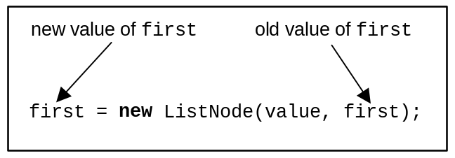
5. The very first time that addFirst() is called, the instance variable, first, will be null. A new node is constructed with the values value and null and now first points to this new node. The constructor provides a new node between the variable first and the node that first formerly referenced.

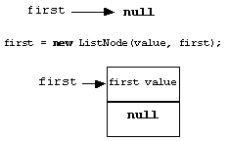 | before the call of the constructor  call the constructor, first is passed as a null value  first is changed, references the newly constructed node

6. The second time that addFirst() is called, first is already pointing to the first node of the linked list. When the constructor is called, the new node is constructed and placed between first and the node first used to point to.

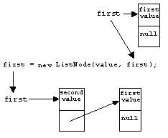

The value of first passed to the ListNode constructor is used to initialize the next field of the new node.

D. Traversing a Linked List - Method printList

1. To traverse a list means to start at one end and visit all the nodes. In the case of method printList, the task is to print the value field from each node.

public class SinglyLinkedList{

...
public void printList(){

ListNode temp = first; // start at the first node
while (temp != null) {
System.out.print(temp.getValue() + " ");
temp = temp.getNext(); // go to next node
}
}
...
}

- We need a variable to traverse through the list so temp is created. Because temp is an alias to first, we can use it to traverse the list without altering the reference to the start of the list. The ListNode variable, temp, will contain null when we are done.

b. Until temp equals null, the while loop will do two steps at each node; print the data field, then advance the temp reference.

c. The statement, temp = temp.getNext(), is a very important one, this moves temp to the next node.

E. Pitfalls of Linked Data Structures

1. A linked list must end with a null value. Without such a marker at the end of the list, a routine cannot “see” the end of the data structure. This assignment of a null value at the end of the list is often taken care of when a new node is packaged or through the use of a constructor.

2. When a reference variable is null, it is a programming error to invoke one of its methods or to try to access one of its instance variables. For example, a program may maintain a reference to the first node of a linked list, as follows:

ListNode first;

Initially, the list is empty and first is the null reference. At this point, it is a programming error to invoke one of the first’s methods. The error would occur as a NullPointerException.

F. Building an Ordered Linked List

1. If data are supplied in unordered fashion, building an ordered linked list from the data becomes a harder problem. Consider the following cases for inserting a new value into the linked list:

- Insert the new value into an empty list.

- Insert the new value at the front of the list.

- Insert the new value at the end of the list.

d. Insert the new value between two nodes.

2. Suppose the data was supplied in this order.

42 6 95 12 <eof>

The resulting ordered linked list looks like this:

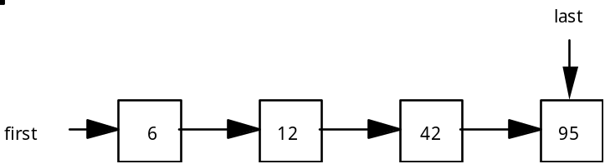

- Two of the cases are easy to identify and solve: the empty list case (a) and placing the new value at the front of the list (b). Adding the value to the end of the list (c) is easy to identify and solve if you maintain a marker to the last node. To assist us in our discussion of linked list algorithms, two definitions will be helpful:

- An internal pointer is one that exists inside a node. An internal pointer joins one node to the next in the linked list.

- An external pointer is one that points to a node from outside the list. Every linked data structure must have at least one external pointer that allows access to the data structure. The linked list in this lesson has two external pointers, first and last.

4. Suppose a fifth value, 61, is to be inserted into the list (d). We can see in the diagram that it will go between the 42 and 95. When inserting a value into the list, we will use helping external pointers, also called auxiliary pointers.

5. It is possible to find the attachment point using just one auxiliary pointer, but we will use two: temp and back. Using two external pointers makes the hookup easier. Finding the attachment point involves a search. The pointer, temp, starts at first and is moved through the list until it is just past the insertion point. The pointer, back, trails temp by one position at each step of the search.

while we haven't found the attachment point{
back = temp; //move back up to temp
temp = temp.getNext(); //advance temp one node ahead
}

The position of our pointers at the end of the search:

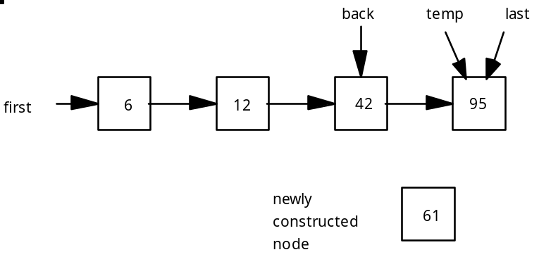
6. The new node needs to be placed between back and temp. If we call this new node newValue, then inserting it into the list would consist of the following steps.

back.setNext(newValue);
newValue.setNext(temp);

G. Linked-List Algorithms

1. Searching an ordered linked list is a sequential search process similar to what we just covered with insertion. A linked list is not a random access data structure. You cannot jump to the middle of a linked list. Only sequential moves are possible. The search function could return a value or a pointer to that cell.

2. Deleting a value involves the following steps:
- Locating the value (if it exists) to be deleted.

- Re-hooking pointers around the node to be deleted.

- Updating first or last if necessary.

H. Static vs. Dynamic Data Structures

1. An array is a somewhat static data structure that has the following advantages and disadvantages:

Advantages of an array | Disadvantages of an array
1. Easy to implement and use  2. Fast, random-access feature | 1. Memory is usually wasted  2. Inserting/deleting is slower

2. A linked list (LL) is a dynamic data structure that has the following advantages and disadvantages:

Advantages of LL | Disadvantages of LL
1. Memory is allocated when the program is run; therefore, the data structure is only as big as it needs to be.  2. Memory is conserved. | 1. Each node of the list takes more memory.  2. The data structure is not random access so processing must be done in sequential order.

I. Doubly-Linked Lists

1. The node of a doubly-linked list will contain the information field and two reference fields. One reference will refer to a previous node while the other reference will refer to the next node in the list.

2. The following class definitions will be used:

public class DListNode{
private Object value;
private DListNode next;
private DListNode previous;

// Constructor:
public DListNode(Object initValue,
DListNode initNext,
DListNode initPrevious){

value = initValue;
next = initNext;
previous = initPrevious;
}

public Object getValue(){
return value;
}

public DListNode getNext(){
return next;
}

public DListNode getPrevious(){
return previous;
}

public void setValue(Object theNewValue){
value = theNewValue;
}

public void setNext(DListNode theNewNext){
next = theNewNext;
}

public void setPrevious(DListNode theNewPrevious){
previous = theNewPrevious;
}
}

3. Figure 29-3 illustrates a doubly-linked list, of type DListNode containing Integer objects.

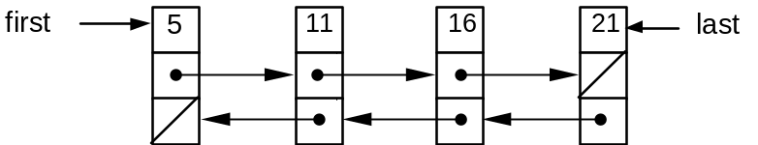
Figure 29-3

4. A null value must be placed at each end of the list to signify the end of the data structure. In the diagram, a null is indicated with the diagonal line.

5. A doubly-linked list should have two external references to access the data structure. In the case above, first and last are the two entry points.

6. A doubly-linked list can be traversed in either direction.

7. Inserting values into an ordered doubly-linked list is a similar process to the algorithm used with a singly-linked list. However, the number of reference manipulations will double.

8. The addition of a new node to a position between two existing nodes will require four reference hookups.

J. Deleting from a Doubly-Linked List

1. The same special cases that we saw for singly-linked lists also apply to doubly-linked lists.

2. Deletions require updating both the next and previous pointers.

SUMMARY/ REVIEW: | You have just learned your first dynamic data structure, a linked list. The concept of indirection makes dealing with references a bit more difficult, but careful reading and lots of diagrams will help. Following a working program is a good start, but only by writing code will you develop proficiency with lists. The doubly-linked list is an extension of the basic linked list.

ASSIGNMENT: Code for Lesson: ListNode.java, ListDemo.java, SinglyLinkedList.java
Lab Assignment AB29.1, List1
Lab Assignment AB29.2, OrderedList
Lab Assignment AB29.2 Data File, file20.txt
Lab Assignment AB29.3, DoublyLinkedList
Lab Assignment AB29.3 Data Files, file3.txt, file10.txt
Worksheet AB29.1, Linked List

* Adapted from the College Board’s AP Computer Science AB: Implementation Classes and Interfaces.

